AI&DS 202@DESKTOP-8MGF9NT MINGW64 ~

**$ git --version**

git version 2.43.0.windows.1

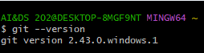

AI&DS 202@DESKTOP-8MGF9NT MINGW64 ~

**$ cd**



AI&DS 202@DESKTOP-8MGF9NT MINGW64 ~

**$ ls**

AppData/ Downloads/ 'My Documents'@ OneDrive/ SendTo@ ntuser.dat.LOG2

'Application Data'@ Favorites/ NTUSER.DAT Pictures/ 'Start Menu'@ ntuser.ini

Contacts/ IntelGraphicsProfiles/ NTUSER.DAT{a2332f18-cdbf-11ec-8680-002248483d79}.TM.blf PrintHood@ Templates@

Cookies@ Links/ NTUSER.DAT{a2332f18-cdbf-11ec-8680-002248483d79}.TMContainer00000000000000000001.regtrans-ms Recent@ Videos/

Desktop/ 'Local Settings'@ NTUSER.DAT{a2332f18-cdbf-11ec-8680-002248483d79}.TMContainer00000000000000000002.regtrans-ms 'Saved Games'/ git-dvcs/

Documents/ Music/ NetHood@ Searches/ ntuser.dat.LOG1

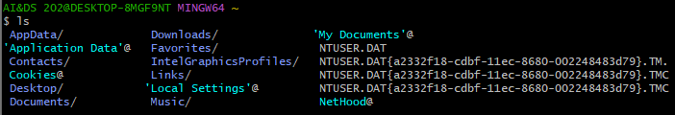

AI&DS 202@DESKTOP-8MGF9NT MINGW64 ~

**$ cd t21-73/**



AI&DS 202@DESKTOP-8MGF9NT MINGW64 ~/t21-73

**$ mkdir git-dvcs**



AI&DS 202@DESKTOP-8MGF9NT MINGW64 ~/t21-73

**$ cd git-dvcs/**



AI&DS 202@DESKTOP-8MGF9NT MINGW64 ~/t21-73/git-dvcs

**$ git config --global**

usage: git config [<options>]

AI&DS 202@DESKTOP-8MGF9NT MINGW64 ~/t21-73/git-dvcs

**$ git config --global user.name "harshit"**

AI&DS 202@DESKTOP-8MGF9NT MINGW64 ~/t21-73/git-dvcs

**$ git config --global user.email "harshitsmestry@gmail.com"**

AI&DS 202@DESKTOP-8MGF9NT MINGW64 ~/t21-73/git-dvcs

**$ git config --global --list**

user.name=harshit

user.email=[harshitsmestry@gmail.com](mailto:harshitsmestry@gmail.com)

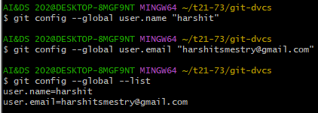

AI&DS 202@DESKTOP-8MGF9NT MINGW64 ~/t21-73/git-dvcs

**$ mkdir git-demo-project**



AI&DS 202@DESKTOP-8MGF9NT MINGW64 ~/t21-73/git-dvcs

**$ cd git-demo-project/**



AI&DS 202@DESKTOP-8MGF9NT MINGW64 ~/t21-73/git-dvcs/git-demo-project

**$ git init**

Initialized empty Git repository in C:/Users/AI&DS 202/t21-73/git-dvcs/git-demo-project/.git/



AI&DS 202@DESKTOP-8MGF9NT MINGW64 ~/t21-73/git-dvcs/git-demo-project (master)

**$ ls -a**

./ ../ .git/



AI&DS 202@DESKTOP-8MGF9NT MINGW64 ~/t21-73/git-dvcs/git-demo-project (master)

**$ git add .**



AI&DS 202@DESKTOP-8MGF9NT MINGW64 ~/t21-73/git-dvcs/git-demo-project (master)

**$ git status**

On branch master

No commits yet

nothing to commit (create/copy files and use "git add" to track)

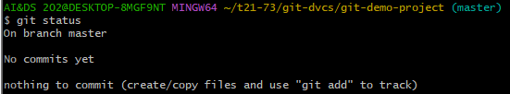

AI&DS 202@DESKTOP-8MGF9NT MINGW64 ~/t21-73/git-dvcs/git-demo-project (master)

**$ git add .**



AI&DS 202@DESKTOP-8MGF9NT MINGW64 ~/t21-73/git-dvcs/git-demo-project (master)

**$ git status**

On branch master

No commits yet

Changes to be committed:

(use "git rm --cached <file>..." to unstage)

new file: ex1.jpg

new file: ex2.jpg

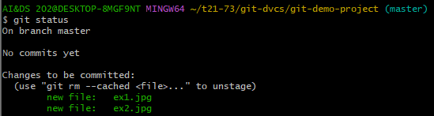

AI&DS 202@DESKTOP-8MGF9NT MINGW64 ~/t21-73/git-dvcs/git-demo-project (master)

**$ git commit -m "First Commit"**

[master (root-commit) ae06ff4] First Commit

2 files changed, 0 insertions(+), 0 deletions(-)

create mode 100644 ex1.jpg

create mode 100644 ex2.jpg

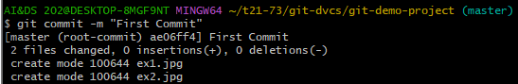

AI&DS 202@DESKTOP-8MGF9NT MINGW64 ~/t21-73/git-dvcs/git-demo-project (master)

**$ git commit -m "First Commit"**

On branch master

Untracked files:

(use "git add <file>..." to include in what will be committed)

ex3.html

nothing added to commit but untracked files present (use "git add" to track)

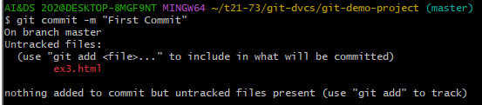

AI&DS 202@DESKTOP-8MGF9NT MINGW64 ~/t21-73/git-dvcs/git-demo-project (master)

**$ git add .**



AI&DS 202@DESKTOP-8MGF9NT MINGW64 ~/t21-73/git-dvcs/git-demo-project (master)

**$ git commit -am "Express Commit"**

[master d2c1321] Express Commit

1 file changed, 0 insertions(+), 0 deletions(-)

create mode 100644 ex3.html

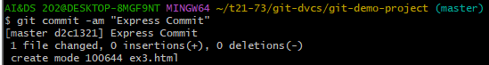

AI&DS 202@DESKTOP-8MGF9NT MINGW64 ~/t21-73/git-dvcs/git-demo-project (master)

**$ nano index.html**



AI&DS 202@DESKTOP-8MGF9NT MINGW64 ~/t21-73/git-dvcs/git-demo-project (master)

**$ git status**

On branch master

nothing to commit, working tree clean



AI&DS 202@DESKTOP-8MGF9NT MINGW64 ~/t21-73/git-dvcs/git-demo-project (master)

**$ touch teststatus**



AI&DS 202@DESKTOP-8MGF9NT MINGW64 ~/t21-73/git-dvcs/git-demo-project (master)

**$ git status**

On branch master

Untracked files:

(use "git add <file>..." to include in what will be committed)

teststatus

nothing added to commit but untracked files present (use "git add" to track)

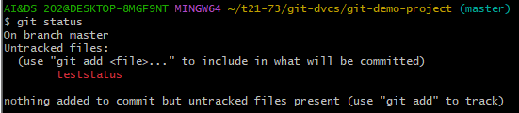

AI&DS 202@DESKTOP-8MGF9NT MINGW64 ~/t21-73/git-dvcs/git-demo-project (master)

**$ git checkout -- teststatus**

error: pathspec 'teststatus' did not match any file(s) known to git



AI&DS 202@DESKTOP-8MGF9NT MINGW64 ~/t21-73/git-dvcs/git-demo-project (master)

**$ git checkout -- ex3.html**



AI&DS 202@DESKTOP-8MGF9NT MINGW64 ~/t21-73/git-dvcs/git-demo-project (master)

**$ git add ex3.html**



AI&DS 202@DESKTOP-8MGF9NT MINGW64 ~/t21-73/git-dvcs/git-demo-project (master)

**$ git add teststatus**



AI&DS 202@DESKTOP-8MGF9NT MINGW64 ~/t21-73/git-dvcs/git-demo-project (master)

**$ git status**

On branch master

Changes to be committed:

(use "git restore --staged <file>..." to unstage)

new file: teststatus

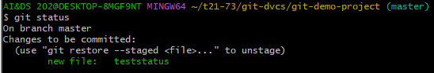

AI&DS 202@DESKTOP-8MGF9NT MINGW64 ~/t21-73/git-dvcs/git-demo-project (master)

**$ git commit -am "Express Commit"**

[master 04c9b93] Express Commit

1 file changed, 0 insertions(+), 0 deletions(-)

create mode 100644 teststatus

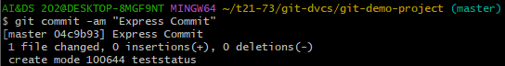

AI&DS 202@DESKTOP-8MGF9NT MINGW64 ~/t21-73/git-dvcs/git-demo-project (master)

**$ git status**

On branch master

nothing to commit, working tree clean



AI&DS 202@DESKTOP-8MGF9NT MINGW64 ~/t21-73/git-dvcs/git-demo-project (master)

**$ git log**

commit 04c9b933932dfcbb31454de8662f92ed67299cd9 (HEAD -> master)

Author: harshit <harshitsmestry@gmail.com>

Date: Fri Jan 19 15:17:55 2024 +0530

Express Commit

commit d2c1321d134aa4d9dd8a1e757973c575e6125d40

Author: harshit <harshitsmestry@gmail.com>

Date: Fri Jan 19 15:13:45 2024 +0530

Express Commit

commit ae06ff48ebc950591441b7e49ee9bc639782cd0a

Author: harshit <harshitsmestry@gmail.com>

Date: Fri Jan 19 15:12:19 2024 +0530

First Commit

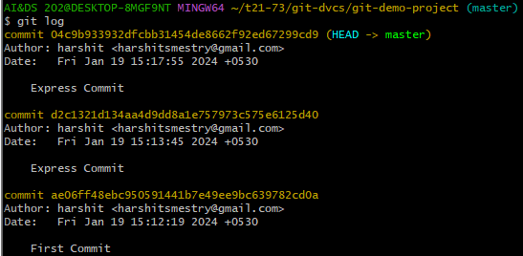

AI&DS 202@DESKTOP-8MGF9NT MINGW64 ~/t21-73/git-dvcs/git-demo-project (master)

**$ git log --oneline**

04c9b93 (HEAD -> master) Express Commit

d2c1321 Express Commit

ae06ff4 First Commit

